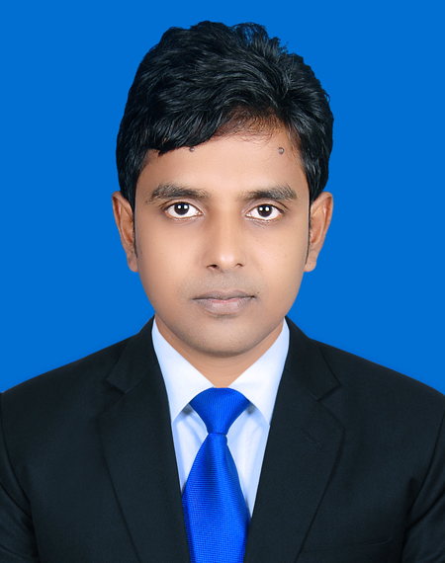

**RESUME**

**OF**

**MD. Imran Hasan**

**Mobile: +8801515261160/01710181786**

**E-mail:imranhasan2006@gmail.com**

**Career Objective**

**To work in a dynamic, intensive environment, where the creativity and interest can be found to develop the skills as well as the career with a strong emphasis on sustained growth and development.**

**Academic Records**

* **B.Sc in Engineering :-**
* **Degree : B.Sc in Electrical & Electronics Engineering.**
* **University : Green University of Bangladesh (GUB).**
* **Subject : Electrical & Electronics Engineering.**
* **Passing Year : 2022**
* **CGPA : 3.58 (out of 4.00)**
* **Diploma in Engineering :-**
* **Degree : Diploma in Power Engineering.**
* **Institute Name : Dinajpur Polytechnic Institute.**
* **Board : Bangladesh Technical Education Board (BTEB), Dhaka.**
* **Technology : Power Technology.**
* **Passing Year : 2012**
* **CGPA : 3.37 (out of 4.00)**
* **Secondary School Certificate:-**
* **Degree : S.S.C**
* **School Name : Muradpur High School.**
* **Board : Bangladesh Technical Education Board (BTEB), Dhaka.**
* **Group : Building Maintenance.**
* **Passing Year : 2008**
* **GPA : 4.36 (out of 5.00)**

**Industrial Attachment**

* **I did my Industrial Attachment Three months in Proton Service Center.**

**Computer Literacy**

* **Package Program: MS Word, MS Excel.**
* **Others : E-mail and Internet Browsing**

**Working Experience (1)**

**Area of Experience : Mechanical and Electrical Maintenance.**

**Company Name : Unilon Textiles Ltd.**

**Designation : Assistant Engineer (Mechanical & Electrical)**

**Service Length : 18.12.2021 to till now.**

**Working Experience (2)**

**Area of Experience : Mechanical and Electrical Maintenance.**

**Company Name : Opex & Sinha Textile Group.**

**Designation : Assistant Engineer (Mechanical & Electrical)**

**Service Length : 01.02.2016 to to 07.12.2021**

**Working Experience (3)**

**Area of Experience : Mechanical and Electrical Maintenance.**

**Company Name : Opex & Sinha Textile Group.**

**Designation : Sub-Assistant Engineer (Mechanical & Electrical)**

**Service Length : 11.05.2013 to 01.31.2016.**

**Working Experience (4)**

**Area of Experience : Mechanical and Electrical Maintenance.**

**Company Name : Ahsan Composite Ltd.**

**Position held : Sub-Assistant Engineer (Mechanical& Electrical)**

**Service Length : 01.11.2012 to 08.05.2013.**

**Major Responsibilities:-**

* + - * + **Knit Dyeing & Finishing Maintenance of Production Machinery Such as ……**
        + **Motor controlling such as(Direct Online starter, Star-Delta starter, Motor reversed and Forward)Motor fault check, MDM and SDB Board Trobule shooting, Inverter parameter setting, load line calculation, House wiring.**
        + **Pipe line installation, Steam line & water line servicing, all types of motor bearing change, Centrifugal pump mechanical seal change etc.**

**Types of machineries:-**

* + - * + **A.K Machine Capacity 800 & 600 kg.**
        + **Fongs Machine 2000 Hongkong, Capacity 1000, 600, 300 & 50 kg.**
        + **Stenter Machine Moenus Krantz K30 Germany.**
        + **Techninox Machine Portugal Capacity 1000 & 1200 Kg.**
        + **Open Compacting Machine, Ferraro Italy.**
        + **Tubetex Padder & Compactor Machine Tube Tex USA.**
        + **Wet Silting Machine, EL Italy & Dry Silting Machine Fongs, Hongkong.**
        + **Squeezer Machine (Corino).**
        + **Dryer Machine Obermier, Austria & Lk Dryer, Germany.**
        + **Hydro Extractor Machine.**
        + **Sueding Machine Italy.**

**Others Responsibilities**

* + - * + **Factory power plant system monitoring.**
        + **Boiler, Compressor, Generator, General Operation & Trouble Shooting and Servicing.**

**Language Proficiency**

* + - * + **English : Fair reading, writing and speaking ability**
        + **Bengali : Mother tongue.**

**Personal Details**

**Name : Md. Imran Hasan.**

**Father’s Name : Md. Mojibor Rahman**

**Mother’s Name : Mrs. Akhtara Banu.**

**Date of Birth : 01-01-1993**

**Gender : Male**

**Marital Status : Married**

**Religion : Islam**

**Blood Group : O(+)**

**Nationality : Bangladeshi**

**National ID No : 2839968704**

**Permanent Address: Village:-Nunaich, Post:-Godagari, Thana:-Kotowali, Dist:-Dinajpur.**

**Current Location : Madhabdi, Narshingdi.**

**Contact No. : 01515261160/01710181786**

**References**

**Name : Md. Moniruzzaman (Monir).**

**Designation : Manager (Maintenance).**

**Department : Maintenance**

**Organization : Unilon Textiles Ltd.**

**Contact No. : 01716547308.**

**I undersigned, hereby declare that I will be responsible for any wrong information provided here.**

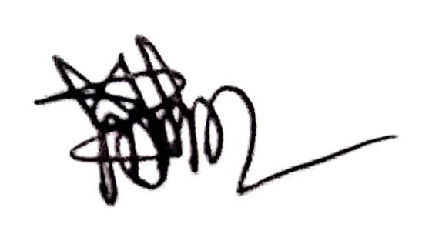

**Date:………….... Md. Imran Hasan**